FaceAge2 Partial PRD (11.19) - $1,000

Partial is a variation of OneClick2 with the following changes:

1. On launch, the following happens (invisible to user):
   1. App opens setup, drops content of Clipboard into selection screen, determines gender, places autodots and generates 3D head. All invisible to user. All figures are based on Genesis 2.

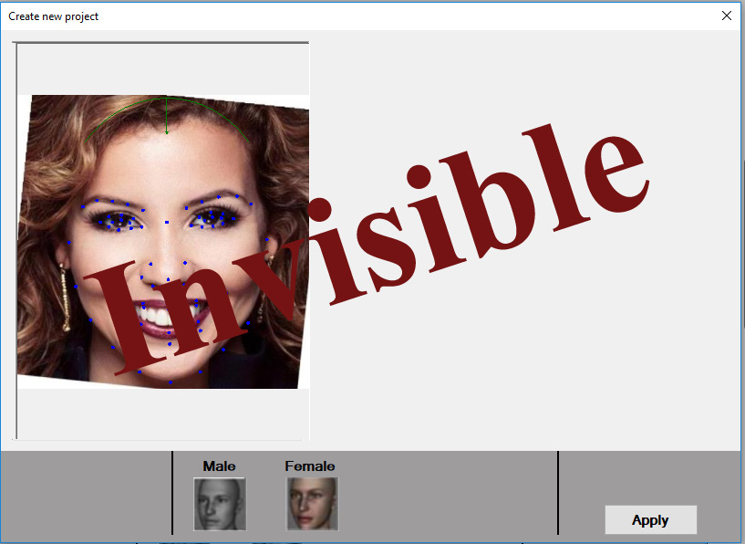

1. 3D head is placed on an invisible layer. On this layer it can be rotated in all three axes!

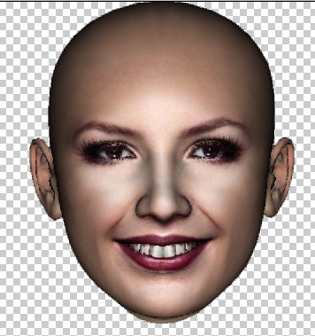

In addition, a floating dialog is added that contains the sliders. About sliders – small change. All sliders default to 50% position. Age slider also shows 50%, which is the adult position. Moving the slider right will morph toward “Old”, moving the slider left will morph toward ” Child”. Note: there is no Male or Female child, only “Child” (which is female). There is also the mirror texture.

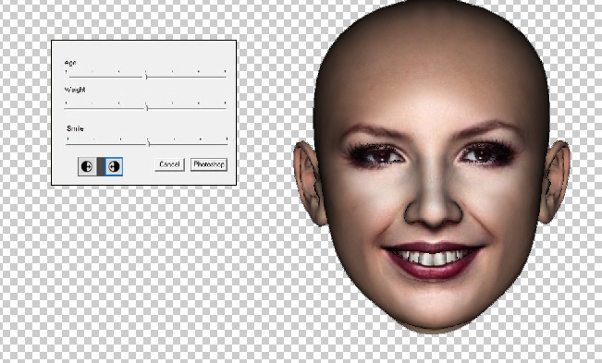

1. Once user clicks on m “Photoshop”, app closes and the screenshot is saved on transparent background as a PNG on a temp location. The size of the PNG image corresponds to the original image size on the clipboard.

Questions about scaling. Not sure how scaling is maintained. WE can assume that the cropping correspondents to the cropping setup in OneClick setup screen. This in turns needs to correspond to the underlying Photoshop image.